**Project Design Phase-II**

**Technology Stack (Architecture & Stack)**

|  |  |
| --- | --- |
| Date | 03October 2022 |
| Team ID | PNT2022TMID13602 |
| Project Name | Airlines Data Analytics for Avaition Industry |
| Maximum Marks | 4 Marks |

**Technical Architecture:**

The Deliverable shall include the architectural diagram as below and the information as per the table1 & table 2

**Example: Order processing during pandemics for offline mode**

**Reference:** [**https://developer.ibm.com/patterns/ai-powered-backend-system-for-order-processing-during-pandemics/**](https://developer.ibm.com/patterns/ai-powered-backend-system-for-order-processing-during-pandemics/)

Guidelines:

1. Include all the processes (As an application logic / Technology Block)
2. Provide infrastructural demarcation (Local / Cloud)
3. Indicate external interfaces (third party API’s etc.)
4. Indicate Data Storage components / services
5. Indicate interface to machine learning models (if applicable)

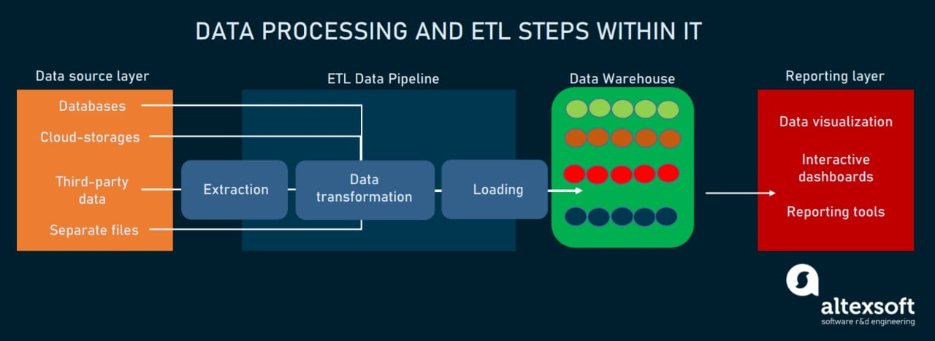

**Table-1 : Components & Technologies:**

|  |  |  |  |
| --- | --- | --- | --- |
| **S.No** | **Component** | **Description** | **Technology** |
|  | User Interface | User can Interact with web Application | HTML, CSS, JavaScript |
|  | Data Preparation | Pre processing of data should be done | Python |
|  | Feature Selection | Feature selection of Dataset using Correlation Feature Selection method. | Python |
|  | Data Analytics | Predication of Flight delay using Decision Tree. | Python |
|  | Data Visualization | Data Type, Configurations etc. | python |
|  | Data Storage | Database Service on Cloud | IBM DB2, IBM Cloudant etc. |
|  | User Interface | Dashboard showing the details of the flight Delay | IHTML, CSS, JavaScript. |

**Table-2: Application Characteristics:**

| **S.No** | **Characteristics** | **Description** | **Technology** |
| --- | --- | --- | --- |
|  | Security Implementations | The main security concern is for users account hence proper login mechanism should be used to avoid hacking | e.g. SHA-256, Encryptions, IAM Controls, OWASP etc. |
|  | Availability | The system shall be available 24 hours a day 7 days a week. User can access at anytime |  |
|  | Performance | The system should require a fair amount of speed especially while browsing through the catalogue |  |

**References:**

[**https://c4model.com/**](https://c4model.com/)

[**https://developer.ibm.com/patterns/online-order-processing-system-during-pandemic/**](https://developer.ibm.com/patterns/online-order-processing-system-during-pandemic/)

[**https://www.ibm.com/cloud/architecture**](https://www.ibm.com/cloud/architecture)

[**https://aws.amazon.com/architecture**](https://aws.amazon.com/architecture)

[**https://medium.com/the-internal-startup/how-to-draw-useful-technical-architecture-diagrams-2d20c9fda90d**](https://medium.com/the-internal-startup/how-to-draw-useful-technical-architecture-diagrams-2d20c9fda90d)